Vaping with FRIENDS: Flexible Robust Instrumentation of Electronic Nicotine Delivery Systems

Edward Sazonov, Senior Member, IEEE, Brett Fassler, Md Rafi Islam, Ashley Schenkel, Delwar Hossain,
Stephen T. Tiffany, and Larry W. Hawk Jr.

Abstract—Electronic nicotine delivery systems (ENDS), commonly referred to as vapes or e-cigarettes, have become more widespread, and their use now rivals or exceeds that of traditional cigarettes in some age groups. Unlike combustible cigarettes, ENDS allow on-demand access to single puffs, and conventional measures of nicotine consumption, such as self-reported cigarette count, do not account well for the particularities of ENDS use. Existing ENDS monitors typically require either a wired connection to the ENDS circuitry or external flow-measurement devices that physically attach to the ENDS airway, making them impractical for widespread use. This paper presents a novel, open-source system for measurement of ENDS vaping behavior in natural environment: Flexible Robust Instrumentation of Electronic Nicotine Delivery Systems (FRIENDS). The FRIENDS device detects near-field electromagnetic pulses generated by current modulation in the ENDS atomizer coil, enabling detection of the timing and duration of atomizer activation. Attachment is non-contact for ENDS that modulate atomizer current; for selected devices that switch the atomizer on and off without modulation, an optional thermistor inserted through a modified mouthpiece is required. The device also includes an exploratory capacitive touch sensor, which was found not to be a reliable proxy for ENDS holding. Initial detectability screening across a library of 90+ ENDS confirmed broad detectability across disposable, pod, and refillable form factors. FRIENDS was validated in three independent studies. Lifecycle bench testing on 26 ENDS devices, from full charge to e-liquid depletion, showed 99.7%± 0.15% (mean ± 95% CI) precision and 97.95% ± 0.87% recall, with a mean puff-duration relative error of 6.88% ± 0.86%. Hybrid Bench/Daily-Carry Robustness Testing over five days, in which all reference puffs were machine-generated while the instrumented ENDS were carried during routine daily activity, yielded 97.6% ± 4.8% precision and 95.5% ± 6.2% recall. Laboratory validation with 22 human participants vaping ad libitum, using video-coded puffs as ground truth, achieved 91.6% ± 7.2% precision and 92.3% ± 7.8% recall. These results support the use of FRIENDS for objective measurement of atomizer-activation events at single-puff resolution under bench, daily-carry, and supervised laboratory conditions. The hardware and software components of FRIENDS are released through open-source repositories.

Index Terms—electronic nicotine delivery systems (ENDS), puff detection, electromagnetic sensing, open source instrumentation, system validation.

I. INTRODUCTION
E
LECTRONIC Nicotine Delivery Systems (ENDS), or vapes/e-cigarettes, deliver nicotine in an aerosol generated by electrically heating e-liquid [1]. ENDS come in a variety of shapes and sizes, such as cigalikes, vape pens, tanks, pods, and closed pod systems [2].
ENDS have become the most commonly used tobacco product among U.S. youth, with 3.6 million youth reporting current use in 2022 [3]. Among U.S. adults, a 6.8 million decrease in the number of adults reporting exclusive cigarette smoking between 2017 and 2023 was accompanied by an approximately 7.2 million increase in exclusive e-cigarette use [4]. Currently, there are large gaps in our understanding of ENDS use and dependence [5], [6], ENDS use as a potential treatment for combustible cigarette smoking [7], [8], and the impact of treatments on ENDS use itself.
For ENDS, the basic unit of behavior is the puff. The ideal measurement system would provide inexpensive, real-time capture of puff quantity and quality (e.g., duration and puff patterns) in natural environments, be non-obtrusive, and be flexible enough for use across the diverse form factors of the rapidly changing ENDS landscape [9].
At present, conventional approaches to assessing ENDS puff behavior are severely limited by relying on self-report, employing a variation of the following question from the widely used Penn State Electronic Cigarette Dependence Index [10]: “How many times per day do you usually use your electronic cigarette? (assume that one “time” consists of around 15 puffs or lasts around 10 minutes): 0-4, 5-9, 10-14, 15-19, 20-29, 30+”.
Emerging work supports the utility of instrumenting ENDS to more accurately assess vaping behavior in the natural environment; however, existing approaches remain limited [11]. First, some systems, including commercially available puff-topography devices, are obtrusive and/or require frequent user intervention. Second, existing instrumentation systems have limited ability to accommodate the wide range of form factors that characterize the rapidly changing ENDS marketplace [9], [12], [13].
One class of approaches embeds sensors within the ENDS device itself. For example, [14] describes a refillable ENDS with built-in puff monitoring that infers puff duration from button-press timing, and [15] presents a custom ENDS incorporating a photometric sensor and pressure transducer to estimate particulate matter and nicotine dose per puff. These custom devices are not broadly available and cannot be used in real-world, large-scale studies.
A second class extends puff-topography methods from combustible cigarettes by measuring aerosol flow through external sensor assemblies. For example, a Bernoulli flow-cell system was developed to assess puff flow rate via differential pressure [16], and the Wireless Portable Use Monitor (wPUM) used an orifice plate coupled with a differential pressure sensor to capture puffing topography in naturalistic settings [17]. While analytically robust, these methods require aerosol flow through external sensor systems, and are challenging to connect to the wide variety of mouthpiece shapes found in ENDS. A more significant limitation is that such systems are often bulky and obtrusive and, in some cases (e.g., wPUM), require user intervention to initiate or record each vaping session, thereby limiting their practicality for real-world monitoring.
A third class attaches external sensors to the ENDS body to detect electrical signals associated with vaping. PuffPacket [13] monitors voltage or current at the heating element via wired probes, enabling puff detection and duration measurement with Bluetooth data transmission, but requiring electrical contact with accessible ENDS circuitry. More recently, PuffEM [18] introduced a surface-mounted magnetometer approach that measures the magnetic flux density produced by atomizer current, eliminating the need for wired access, but was validated on only three ENDS devices and in a five-day field study with two participants using only one ENDS device, i.e., JUUL. FRIENDS uses a different transduction principle: an inductive pickup coil whose induced voltage is proportional to the time derivative of the coupled atomizer current rather than to the field itself. Electromagnetic sensing of atomizer activation is therefore not introduced by the present work; Table 1 summarizes the differences between FRIENDS and prior ENDS monitoring systems.
Table 1. Comparison of instrumented approaches to measuring ENDS use. Entries reflect only characteristics reported in the cited primary sources.
Characteristic | Airflow topography [16],[17],[19] | PuffPacket [13] | PuffEM [18] | FRIENDS (this work)
Sensing principle | Differential pressure / flow | Voltage or current at heater | Surface magnetometer (flux density) | Inductive coil (dI/dt); optional thermistor
Connection to ENDS | Mouthpiece adapter in airway | Wired probes to circuitry | None (surface-mounted) | None for PWM ENDS; mouthpiece modification for selected on/off ENDS
Alters airflow path | Yes | No | No | Only in thermistor configuration; effect not characterized
Device coverage reported | Adapter-dependent | Several ENDS | 3 ENDS | 90+ screened; lifecycle subset
Human validation reported | Laboratory and field | Yes | 5-day field, 2 participants, 1 model (JUUL) | 22-participant supervised laboratory; no unsupervised free-living
User intervention required | Yes for wPUM | No | No | No
Open implementation resources | No | Partial | No | Yes (hardware, firmware, GUI, vaping machine, library)
Notable commercially available systems include the Clinical Research Support System (CReSS) pocket and the Smoking Puff Analyzer Mobile Device (SPA-M) [19], both of which connect directly to the ENDS airflow path. Although widely used in laboratory settings, their use in free-living environments is limited by cost, complexity, and compliance challenges [20]. Additionally, mouthpiece adapters can alter vaping behavior and disrupt nicotine delivery by causing aerosol deposition within the tubing, potentially affecting data validity [21], [22].
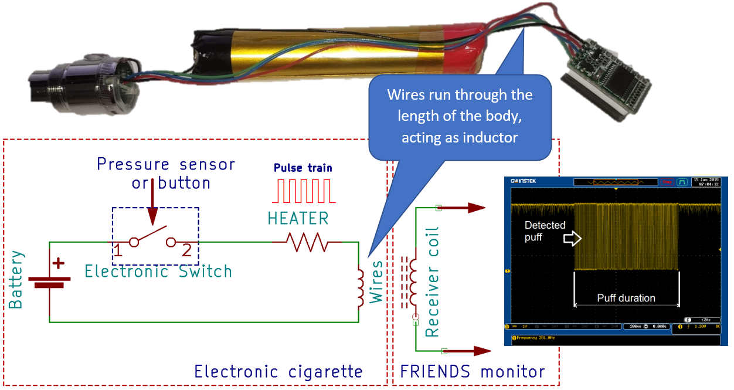
Fig. 1. FRIENDS monitor detects electromagnetic field created by the Pulse-Width Modulated (PWM) current running through the ENDS heater/atomizer.

Instrumentation and measurement systems have been developed for objective monitoring of a wide range of human behaviors, for example, driving behavior [23], postural stability [24], and student classroom engagement [25]. However, comparable instrumentation for continuous, objective measurement of ENDS vaping behavior in the natural environment remains limited.
The present work addresses this gap by introducing a low-burden, externally attached system for measuring puff timing and duration across diverse ENDS devices: Flexible, Robust Instrumentation of ENDS (FRIENDS). FRIENDS addresses shortcomings of previously reported ENDS monitors and offers the following contributions. First, FRIENDS uses an inductive pickup coil that responds to the time derivative of atomizer current. This provides a direct and robust measurement of the timing and duration of atomizer activation without electrical contact with ENDS circuitry (Fig. 1). Second, with near-field detection as the primary sensing modality, the FRIENDS device operates without contact to the ENDS circuitry or airway for ENDS that modulate atomizer current, requiring only attachment to the surface of the vape. For the subset of devices that do not use PWM modulation of the atomizer current, a supplemental thermistor may be used to improve detection accuracy, though this optional configuration requires physical modification of the mouthpiece. Third, because FRIENDS is an externally attachable instrument that is not ENDS-specific, it offers flexible deployment across a variety of ENDS form factors and manufacturers. Fourth, the FRIENDS device is small, requires no user intervention, and provides no feedback to the user, reducing the likelihood of reactivity. Fifth, and central to the contribution claimed here, FRIENDS is released as a complete open-source measurement platform rather than a sensing element alone: sensing hardware and firmware, the optional thermistor confirmation channel, an extraction and analysis GUI, the VM-FRIENDS reference vaping machine, a maintained device-compatibility library, and documented model-specific deployment procedures. This allows broader adoption by the scientific community. Overall, FRIENDS introduces a practical instrumentation system for objective measurement of the basic unit of ENDS use behavior, the puff.

II. Methods

A. Principle of Operation
Every ENDS contains a battery, a heater/atomizer, wiring, and an electronic switch (vape controller) connected to a pressure sensor or a button (Fig. 1). In many ENDS devices the electronic switch creates a pulse width-modulated (PWM) voltage at a frequency of about 100-500 Hz that controls current through the heater, and thus the power delivered to the atomizer to control the amount of produced aerosol. The frequency of the PWM train varies across ENDS brands. Some of the cheaper, typically disposable, ENDS may not generate a pulse train, and act like an on/off switch (Fig. 2).
The ENDS wiring acts as an inductor, creating a varying electromagnetic field in the vicinity of the body that can be picked up by an inductive pickup coil at short distances (~1cm). The initiation of the pulse train coincides with the puff start on most ENDS (and with button press on older models). The pulse-train duration corresponds to the atomizer activation duration and thus serves as a direct objective measure of vaping behavior. For consistency with the behavioral literature, detected atomizer activation events are referred to as 'puffs' throughout this paper. The same is true for on/off pulses for the ENDS that do not use PWM modulation. Inductive pickup operates without direct contact with electrical components of the ENDS, thus allowing measurement of puffs without physical modification of the ENDS device. Similar non-contact inductive coupling principle is used in biomedical instrumentation, for example to localize metallic foreign bodies during surgery [26].
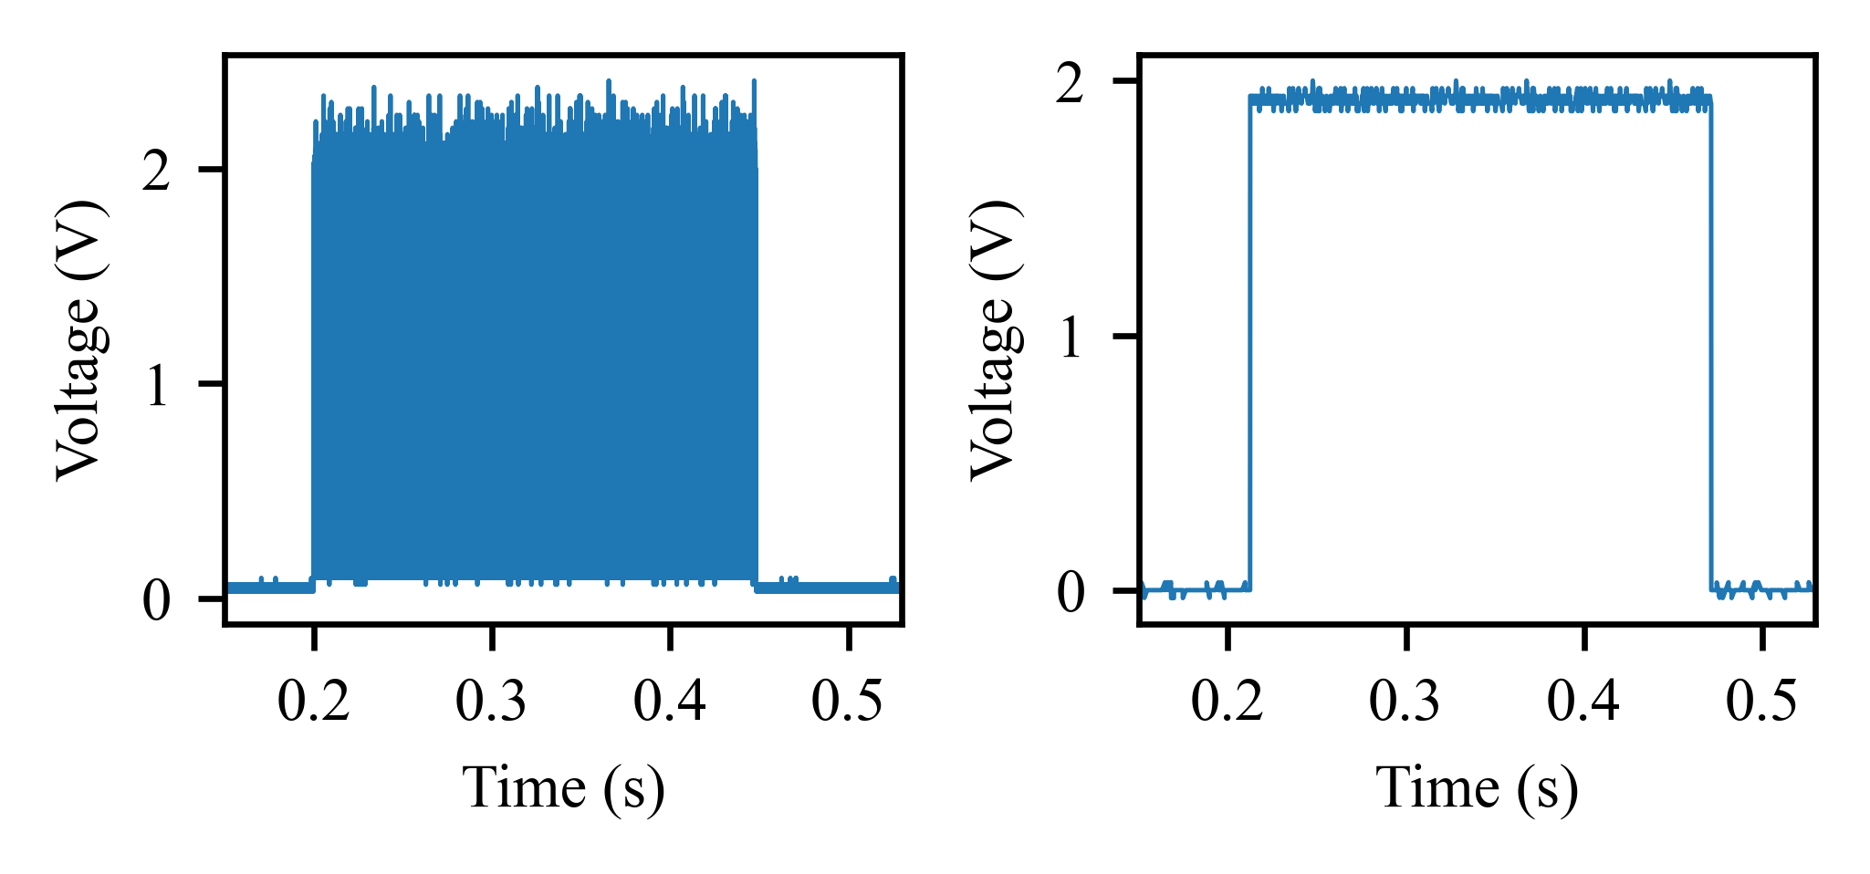
- (b)
Fig. 2. Two types of atomizer activation in ENDS devices: (a) PWM signal generated by the vape controller to regulate power delivered to the atomizer; (b) on/off signal found in simpler disposable ENDS devices.

Fig. 3 shows a low-power, high-gain, high-bandwidth amplifier used by the FRIENDS device. The unipolar current pulse train in the ENDS atomizer induces a voltage in L1 (inductive pickup or “sniffer coil”) proportional to dI/dt and the mutual coupling. The first stage of the band pass filter/amplifier is biased to ~VDD/2 by R7 and R6. C9 bypasses R8 at higher frequency, so the bias node becomes an AC ground at the pulse-train frequencies. At very low frequency/DC, C9 is “open,” so the input sees only the large bias resistors and the net gain falls. C10 shunts high frequency interference to ground directly at the coil. The second stage further amplifies the signal to the point of output saturation. Thus, this sensor picks up the PWM signal produced by ENDS atomizer through inductive coupling, filters out low frequency and high frequency interference, and amplifies the useful signal to produce a 0/Vdd output (Fig. 3, SENSOR_OUT) that connects to the microcontroller.

B. FRIENDS Hardware and Firmware
A functional block-diagram of the FRIENDS device is shown in Fig. 4. In addition to the inductive pickup sensor described above, the device integrates two additional sensors. A capacitive touch sensor (AT42QT1011, Microchip Technology) detects contact with the FRIENDS enclosure and was included as an exploratory channel intended to serve as a proxy for ENDS holding
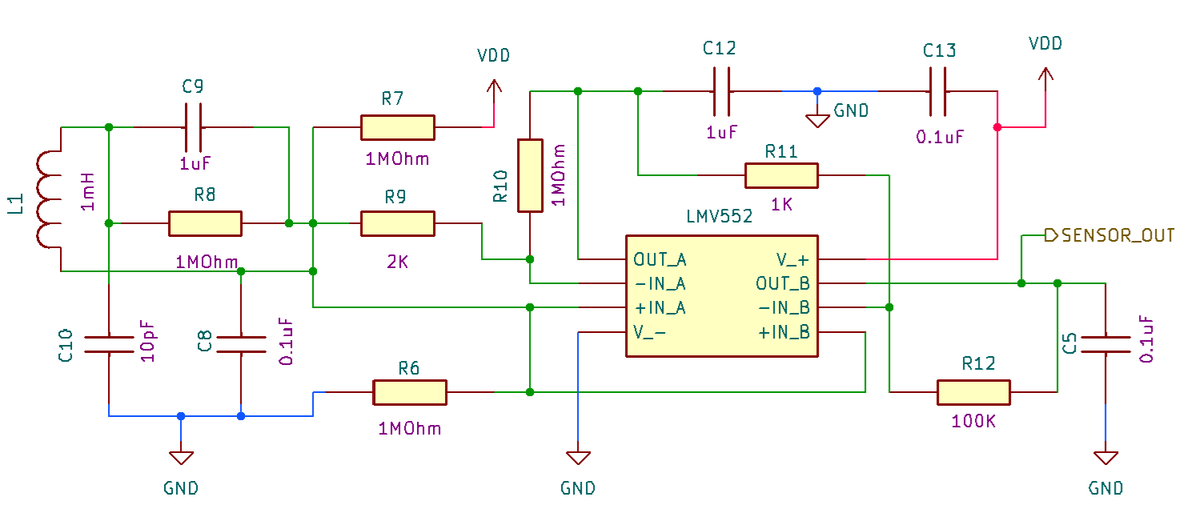
Fig. 3. Schematic of the FRIENDS’s inductive pickup sensor.
The sensors are interfaced to a low-power 16-bit microcontroller (MSP430G2433IRHB32R, Texas Instruments) that coordinates sensor data acquisition, control logic, and power management. External 512 KB flash memory (MX25L4006E, Macronix International) connected using SPI is used for data logging. The device is powered by a rechargeable 110 mAh Li-Po battery, providing over 10 days of continuous operation on a single charge.
Fig. 5 illustrates the hardware of the FRIENDS device. Fig. 6 shows the device housed within a custom 3D-printed enclosure with the thermistor connected for temperature sensing and attached to a commercially available disposable ENDS (Geek Bar Pulse 7500/15000).
The firmware for the FRIENDS device (written in C) uses an interrupt-driven architecture to capture and log vaping events: a hardware interrupt is triggered whenever either the inductive pickup detects a puff or the touch sensor registers contact. Interrupts are also triggered at the end of a puff or end of contact with the touch sensor. Precise time with resolution of (1/32768 s, ~30 us) is kept by an internal timer clocked by a crystal oscillator. In response to a trigger, an event timestamp in extended POSIX format containing date, time, and fractions of the second (Table 2) is written to the flash in combination with type of the event (PUFF ON/PUFF OFF, TOUCH ON/TOUCH OFF). For each of these events, the ADC reads the temperature from the thermistor, and this value is also logged in flash memory. Each event requires 8 bytes of storage to store the event type, extended timestamp, and temperature, with the flash capacity allowing for a total of 65536 events to be stored on the device.
Data stored on the FRIENDS device are accessed and decoded using a Python-based graphical user interface (GUI) [28], [29]. The FRIENDS GUI interfaces with FRIENDS devices through USB serial communication and provides tools for synchronizing the internal clock, managing flash memory, extracting raw data, decoding extended POSIX timestamps, and visualizing ENDS usage. The event code, POSIX seconds, and fractional seconds are extracted, and the timestamps are converted into a local, readable datetime format. The data are then processed using the puff detection algorithm described in the next section, and the results are visualized in daily 24-hour graphs (Fig. 7).
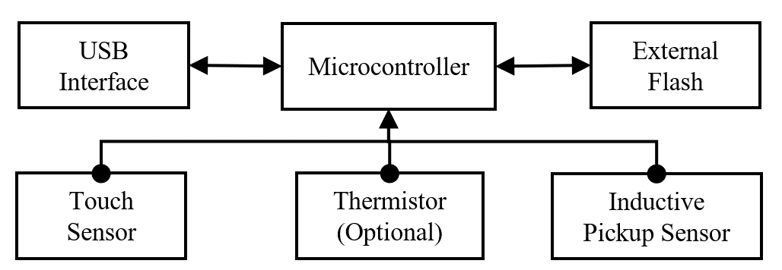
Fig. 4. Functional Block Diagram of FRIENDS device.

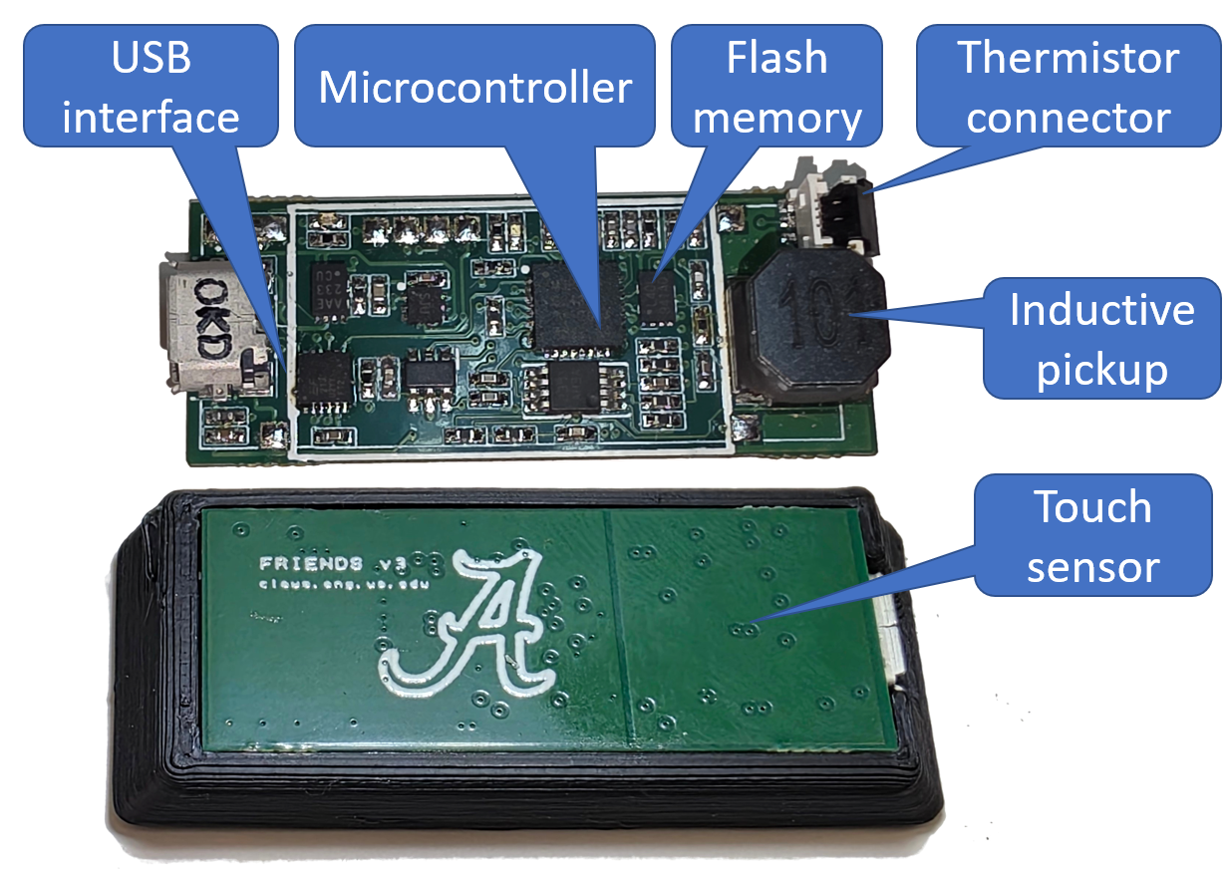
Fig. 5. Electronics of the FRIENDS device (front and back).

C. Puff Detection and Stitching
Puff detection is performed within the GUI software [28]. The detection algorithm depends on the type of atomizer activation in a specific ENDS device (Fig. 2).
For ENDS that have consistent PWM modulation of the atomizer current over the life of the ENDS, only the inductive pickup sensor events (PUFF_ON/PUFF_OFF) are used, as characterized in the FRIENDS library [30]. After extracting these events from flash memory, the GUI calculates atomizer activation duration by finding the difference in puff start and end times. To reduce false positive detections caused by electromagnetic noise, puffs with durations shorter than a predefined threshold (e.g., 400 ms, as determined further) are discarded.
Table 2. Example of Extended POSIX Timestamp and converted timestamp
Extended POSIX timestamp | Event Code | Standard POSIX in HEX format | Fractional Part | Event | Converted timestamp
1000672103476BDF | 1000 | 67210347 | 6BDF | PUFF_ON | PUFF_ON 2024-10-29 10:46:15.421371
20006721034A8B2B | 2000 | 6721034A | 8B2B | PUFF_OFF | PUFF_OFF 2024-10-29 10:46:18.543625
50000000000001E0 | 5000 | - | - | TEMP_ON | TEMPERATURE_ON 480
6000000000000098 | 6000 | - | - | TEMP_OFF | TEMPERATURE_OFF 152
300067210AA0454C | 3000 | 67210AA0 | 454C | TOUCH_ON | TOUCH_ON 2024-10-29 11:17:36.270691
400067210AA06241 | 4000 | 67210AA0 | 6241 | TOUCH_OFF | TOUCH_OFF 2024-10-29 11:17:36.383804

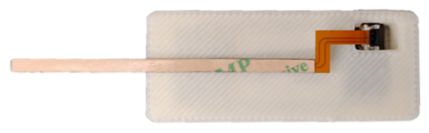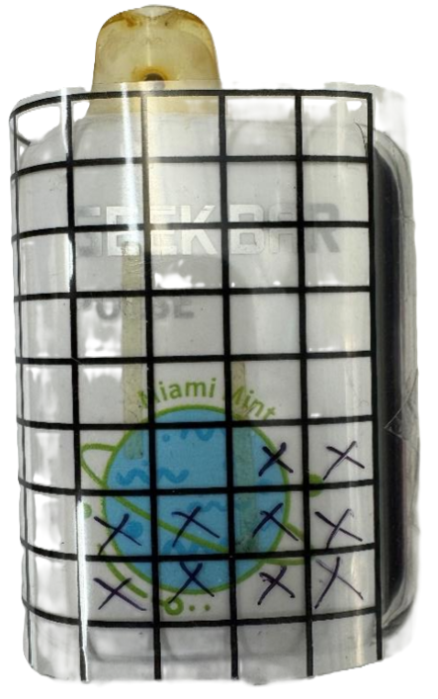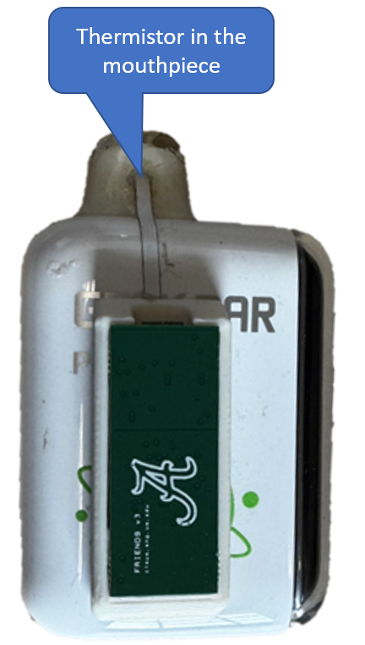
- b) c)

Fig. 6. a) FRIENDS with thermistor cable connected; b) sensitivity zones mapped on Geek Bar Pulse 7500/15000 ;c) installed.
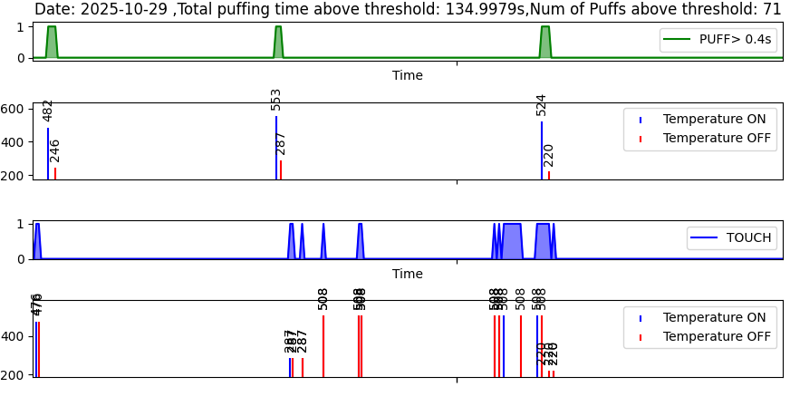Fig. 7. Example of FRIENDS data visualized by the GUI.

For ENDS models that do not produce a strong or consistent PWM signal, the inductive sensor alone may not provide sufficiently accurate readings because the inductive pickup detects only the current changes at the beginning and end of each puff, which are not typically distinguishable from electromagnetic noise. For such devices, thermistor readings can be used to improve puff-detection accuracy. The thermistor values are recorded at the start and end of each puff event. If the temperature at the end of a puff is 2 ADC units higher than at the beginning, the puff is considered a true positive and retained for further processing; otherwise, it is discarded.
The thermistor is also used for “puff stitching” in situations where multiple consecutive puffs are detected. The temperature at the end of puff n is evaluated against the starting temperature of the subsequent puff n + 1. If the starting temperature of puff n + 1 is higher than the ending temperature of puff n, the two puffs are concatenated. After concatenation, any puff shorter than a predefined duration is further evaluated to determine whether its temperature change exceeds a minimum rise. Puffs not demonstrating a temperature change are discarded. A detailed description of this algorithm is provided in [28].

D. Vape Library and Initial Testing of Detectability
To systematically evaluate detectability and deployment compatibility of FRIENDS across the heterogeneous ENDS landscape, we established the open-source FRIENDS Vape Library [30]. The library is a continuously maintained database of ENDS devices that have been tested for detectability by the FRIENDS device. At the time of writing, the library contains data for over 90 ENDS devices spanning disposable closed-system ENDS (e.g., Breeze Pro, Hyde Edge), rechargeable closed-system devices (e.g., Elf Bar, Geek Bar, Lost Mary), pod systems (e.g., JUUL, NJOY ACE), and pod-mod/refillable systems (e.g., SMOK Nord). These devices vary in atomizer drive architecture (PWM-modulated vs. simple on/off switching), form factor, battery capacity, and e-liquid volume, collectively representing the major categories of commercially available ENDS.
For each device in the library, initial detectability testing follows a standardized SOP [31] using the VM-FRIENDS electromechanical vaping machine [32]. VM-FRIENDS is an open-source, low-cost system that delivers programmable puff sequences with precise control over puff volume, duration, flow rate, and inter-puff duration using a linear actuator driving a syringe as a lung analogue. To identify the detection sensitivity zone for each ENDS device, an 8 mm grid printed on transparency paper is wrapped around all accessible surfaces of the ENDS body. Vaping is simulated using the VM-FRIENDS machine, the FRIENDS device is systematically scanned across each grid position; positions where the FRIENDS LED indicator illuminates reliably are marked, producing a spatial sensitivity map. The FRIENDS device is normally placed in the middle of sensitivity zone.
Of the 90+ devices tested for initial detectability, 79 were detectable using the inductive pickup and 13 were not detectable by the current FRIENDS hardware. A subset of 30 detectable devices that were available as brand-new in original packaging was used for lifecycle testing.
FRIENDS is therefore a broadly adaptable platform that requires model-specific compatibility assessment and placement rather than a device-independent monitor. The deployment workflow used throughout this work is: (1) check the FRIENDS compatibility library for the ENDS model; (2) if the model is absent, map its sensitivity zone with the 8 mm grid procedure described above; (3) attach FRIENDS at the centroid of the sensitivity zone in the documented orientation; (4) add the in-mouthpiece thermistor only for models that require thermistor-assisted detection; (5) run a 10-puff confirmation test (3 s puffs, 10 s inter-puff interval); and (6) if confirmation fails, repeat the placement mapping and verify ENDS operation, and classify the model as incompatible if reliable detection cannot be established. Absolute tolerance to displacement and orientation change was not quantified; reliable detection was confined to the model-specific zones identified by this procedure.

E. Bench Lifecycle Testing
To evaluate the accuracy of the FRIENDS device in detecting puff events across the full lifecycle of an ENDS, controlled bench tests were conducted on a subset of 30 devices spanning the major ENDS categories. The FRIENDS device was attached to an ENDS and a standardized puff sequence was delivered by VM-FRIENDS. The thermistor was used for testing unless it was found that it could not be installed onto an ENDS due to physical constraints (i.e., pod and pod-mod ENDS). Because puffing was actuated by the VM-FRIENDS machine, the touch sensor was not used in puff detection.
A puffing session was performed as a sequence of eighty puffs with a puff volume of 120 mL, puff duration of 3 s (a flow rate of 40 mL/s), and inter-puff duration of 18 s. Upon completion of each session, the ENDS device was detached from VM-FRIENDS, and the test data were stored. The ENDS device was recharged to full capacity when the battery level fell below 10% or when a low-battery indication was observed. If either condition occurred during a puffing session, the test was halted, data were recorded, and the device was recharged to full capacity. The puffing sessions were repeated until the ENDS could no longer complete a full 80-puff session due to insufficient e-liquid (defined as less than 5% remaining). This approach ensured that each test spanned the operational lifetime of the ENDS device. The number of expected puffs and puffs recorded by the FRIENDS device were recorded after each test. A detected puff was labeled a true positive (TP) if detection matched a puff recorded by VM-FRIENDS. It was labeled a false positive (FP) if no corresponding VM-FRIENDS puff was present. A false negative (FN) was defined as a puff recorded by VM-FRIENDS that was not detected by FRIENDS. Puff detection accuracy was evaluated using three complementary metrics computed across puffing sessions: mean relative error (RE) of puff count per session (the absolute relative difference between expected and detected puffs in each 80-puff session, averaged across all sessions), precision, and recall, each reported with 95% confidence intervals. The accuracy of atomizer activation duration measurement was evaluated as the mean RE between FRIENDS-measured and VM-FRIENDS-programmed durations, with 95% CI across sessions.
Of the 30 devices selected for lifecycle testing, four lost detectability before completion and were excluded, leaving 26 that remained detectable throughout their full operational lifetime (Table 3). Of these, 17 required thermistor-assisted detection.

F. Hybrid Bench/Daily-Carry Robustness Testing
While bench testing established detection accuracy under controlled conditions, deployment may expose FRIENDS to electromagnetic interference, body movement, changes in device orientation, and temperature variation. We therefore conducted a five-day hybrid bench/daily-carry environmental robustness study. All reference puffs were generated by VM-FRIENDS, while the instrumented ENDS were carried during routine daily activities between machine-actuated sessions. This design evaluated detection robustness under daily-carry conditions but did not assess unsupervised human vaping.

Two commercially available auto-draw ENDS were selected to represent distinct device categories: the NJOY ACE, a pod system relying on inductive pickup alone, and the Geek Bar Pulse X (in pulse mode), a rechargeable disposable requiring thermistor-assisted detection. A thermistor was integrated by drilling a small hole into the mouthpiece, inserting the sensor, and sealing the opening with a dental bead [31].
The ENDS devices with attached FRIENDS were carried by a member of the research team in separate pockets for approximately 8 hours per day over five consecutive days during routine daily activities. During each day, 90 controlled puffs were simulated by VM-FRIENDS machine. The 90 puffs were delivered in three sessions per day, each consisting of 30 puffs. To reflect a range of puff durations, inhalation and exhalation durations were set to 1 second in the first session, 2 seconds in the second session, and 3 seconds in the third session [13], [23]. An 18-second inter-puff interval was maintained between puffs, with a 2-hour gap between sessions.
At the end of each day, data from the FRIENDS device were extracted and analyzed to compute precision, recall and F1 score. A detection threshold was used to reduce FP puffs caused by electromagnetic interference, most of which were of very short duration (a few milliseconds). Any puff with duration less than 0.4s was discarded.
The ENDS devices were recharged after each session if the Geek Bar Pulse X battery level dropped to approximately 5–10% or if the NJOY ACE indicated a low battery with its LED. The NJOY ACE cartridge was replaced whenever the e-liquid level was nearly depleted, resulting in three cartridge replacements during the study. After completing a total of 450 simulated puffs across five days, the Geek Bar Pulse X e-liquid level was observed to decrease to 14%. The FRIENDS devices themselves were not recharged during the five-day test.

G. Laboratory Validation with Human Participants
To validate FRIENDS against naturalistic human vaping and to evaluate the touch sensor's contribution to detection, a laboratory study was conducted with video-recorded ad libitum vaping as ground truth.
Twenty-two adults (age 18+) with established daily or near-daily ENDS use (≥5 days/week for ≥3 months) were recruited. Participants were excluded for frequent recent use of nicotine/tobacco products other than cigarettes, recent use of smoking cessation or antipsychotic medications, or diagnoses of schizophrenia or bipolar disorder. All procedures were approved by the University at Buffalo Institutional Review Board, and all participants provided informed consent.
At a baseline session, study staff assessed compatibility of each participant's personal ENDS against a list of devices with confirmed FRIENDS thermistor-mode compatibility. Six participants (27%) continued using their own ENDS; the remaining 16 (73%) purchased a compatible device from the FRIENDS Vape Library [30], with 7 of these switching to a different model of the same brand. Approximately one week later, participants returned for a 2.5-hour laboratory visit with their fully charged ENDS. Study staff attached the FRIENDS monitor according to device-specific placement protocols documented in the library and confirmed detection with a 10-puff validation test (3 s puffs, 10 s inter-puff interval). Participants then completed a 2-hour ad libitum vaping session in a ventilated room, during which they were free to vape as much or as little as they wished while engaging in leisure activities.
The session was recorded by two pan-tilt-zoom cameras at 25 frames per second. Puff behavior was coded from video by trained raters (>90% inter-rater agreement) using Observer XT (Noldus), with puff onset defined as the first frame of mouthpiece-to-lip contact and offset as the last. FRIENDS puff data were converted to a 25 Hz time series and temporally aligned with video-coded puffs. Each FRIENDS-detected puff was classified as a TP (temporal overlap with a video-coded puff), FP (no matching video puff), or FN (undetected video puff). Precision, recall, and F1 score were computed from these classifications. To evaluate the contribution of the touch sensor, all metrics were recalculated using only FRIENDS-detected puffs that temporally overlapped a touch sensor activation.
FRIENDS timestamps were derived from a 32.768 kHz crystal-referenced timer. Taking a nominal crystal tolerance of +/-20 ppm, the accumulated timing error over a 2 h session is bounded at approximately +/-0.14 s, which is small relative to the mean puff duration but not negligible relative to the shortest puffs. [AUTHOR ACTION: state the actual clock-synchronization event used between FRIENDS and the video record, whether any drift correction was applied, and the measured or bounded residual alignment error. State the matching rule explicitly: the minimum temporal overlap required for a FRIENDS atomizer-activation event to be matched to a video-coded mouthpiece-contact event, and how one-to-one matching was enforced when several events overlapped.]
Puff duration for video data was defined as the interval between mouthpiece-to-lip contact onset and offset, whereas puff duration for FRIENDS was defined as the interval between atomizer activation onset and offset. For each participant, mean puff duration was computed separately from video and FRIENDS data. Agreement between the two measures was assessed using the Pearson correlation across participant-level means (N=22) and mean bias (video minus FRIENDS duration).

H. Statistical Analysis and Data Quality Control
The three studies have different units of analysis and different estimands, and are analyzed accordingly. For lifecycle bench testing, the estimand is aggregate detection performance over the tested device set. Precision, recall, and F1 are computed from pooled TP, FP, and FN counts, and uncertainty is estimated by ) cluster-robust ratio-of-totals estimator (Ref: Cochran, 1977), with device as the sampling cluster. Because pooled counts are dominated by devices contributing the most puffs, the device-level distribution of each metric is reported alongside the pooled estimate. Session-level intervals within a single device are reported only in the supplementary device-level table and are not used to support claims about the device set.
For the laboratory human study, both pooled (micro-averaged) metrics computed from total TP, FP, and FN counts and participant-level (macro-averaged) metrics are reported and labeled separately, since they answer different questions. Macro F1 is the mean of participant-specific F1 values rather than a value derived from mean precision and mean recall. .Pooled-metric uncertainty uses the same cluster-robust ratio-of-totals estimator (Cochran, 1977), with participant as the sampling cluster. Participant-level confidence intervals are instead obtained by a percentile bootstrap (10,000 resamples of the 22 participants with replacement, fixed seed), used rather than a normal-theory interval because several participants sit at the 1.0 precision/recall boundary. . Duration agreement is assessed by Bland-Altman analysis in addition to Pearson correlation, since correlation measures association and not agreement.
For the hybrid bench/daily-carry robustness testing, only two ENDS models were evaluated. Results are therefore reported per model across the five days with descriptive day-to-day variability; no interval implying inference across ENDS models is reported. All intervals are reported as 95% CI [lower, upper] rather than as symmetric +/- values when the bootstrap interval is asymmetric.
[AUTHOR ACTION - to be completed from source records: number of bootstrap replicates for each resampling procedure; the rule applied when a participant-level metric is undefined; the specific data-integrity checks applied during decoding (event-code validity, record length, timestamp monotonicity, valid ON/OFF pairing); the number of sessions and records affected by corrupted or incomplete transfers; and the number excluded or repeated under the stated rule.]

III. Results

A. Bench Lifecycle testing
Table 3 shows the results of the lifecycle bench tests. The puff count was measured accurately over the complete lifespan of 26 ENDS devices, with the largest mean RE of 11.21% for the Offstamp X cube. The FRIENDS device measured the number of puffs with less than 2% mean RE for 19 out of the 26 ENDS devices. Notably, puff count accuracy was robust across closed-system disposable ENDS and refillable pod systems. Agreement between FRIENDS-measured atomizer activation duration and programmed puff duration varied between devices. For the Juul, the recorded atomizer activation duration was within 1% of the total puff duration programmed into VM-FRIENDS. The NJOY ACE, however, had 18.90% error between the recorded and programmed puff durations. The rest of the devices fell between these two, with an average atomizer duration relative error of 6.88% across all ENDS.

B. Hybrid Bench/Daily-Carry Robustness Testing
The results of the hybrid bench/daily-carry robustness testing, incorporating data from both the NJOY ACE and Geek Bar Pulse X ENDS devices, are presented in Fig. 8. To characterize the sensitivity of detection performance to the duration threshold, a day-stratified analysis was performed in which each day was held out in turn and threshold performance was summarized by the mean F1 score across days. Because all reference puffs in this experiment were programmed at 1, 2, or 3 s, this analysis characterizes the rejection of brief interference and the stability of the threshold across days; it cannot establish the prevalence or detectability of genuine sub-second human puffs. For each detection threshold T, the mean F1 score was computed across validation folds, and the shaded region represents the corresponding 95% confidence band.
At low detection thresholds (0–0.2s), the mean F1 score exceeded 0.93, with high recall and comparatively lower precision. Between thresholds of 0.4s and 1.0s, the mean F1 score remained near its maximum (approximately 0.96–0.97), with a relatively narrow confidence band, demonstrating stable performance. This threshold range corresponds to the most reliable operating region for threshold-based puff detection.
Table 3. Bench Lifecycle Testing Results
# | Vape Model | Puff Produced using VM-FRIENDS |  | FRIENDS Measurements
 |  |  |  | Puff Count Measurement |  |  |  |  |  |  | Atomizer Activation Duration RE ± 95% CI (%)
 |  | No. of Puffs | No. of Sessions | Puffs Detected | TP | FP | FN | Precision ± 95% CI (%) | Recall ± 95% CI (%) | Puff Count MAE ± 95% CI (%)
 | Adjust Myflavor | 440 | 11 | 440 | 440 | 0 | 0 | 1±0.00 | 1±0.00 | 0 | 8.91±0.55
 | Artery CL6 | 433 | 7 | 403 | 403 | 0 | 30 | 1±0.00 | 0.93±0.1 | 6.93±9.95 | 9.20±10.11
 | Breeze Pro*^{c} | 400 | 5 | 397 | 397 | 0 | 3 | 1±0.00 | 0.99±0.021 | 0.75±2.08 | 3.42±1.37
 | EBCreate BC 5000* | 450 | 5 | 446 | 446 | 0 | 4 | 1±0.00 | 0.99±0.013 | 0.89±1.30 | 1.29±0.81
 | Elf Bar BC5000* | 448 | 6 | 448 | 448 | 0 | 0 | 1±0.00 | 1±0.00 | 0 | 2.88±1.58
 | Funky Republic ti7000* | 560 | 7 | 558 | 557 | 1 | 3 | 0.99±0.004 | 0.99±0.013 | 0.71±1.31 | 6.79±2.41
 | Fzzybar X20000* | 530 | 5 | 490 | 490 | 0 | 40 | 1±0.00 | 0.93±0.125 | 7.55±12.52 | 6.86±7.63
 | Geek Bar Pulse* | 400 | 5 | 403 | 400 | 3 | 0 | 0.99±0.0136 | 1±0.00 | 0.75±1.39 | 4.39±0.72
 | Hyde IQ5000* | 536 | 8 | 505 | 504 | 1 | 32 | 0.99±0.005 | 0.94±0.053 | 6.16±5.70 | 11.49±7.04
 | Hyde N-bar* | 240 | 3 | 236 | 236 | 0 | 4 | 1±0.00 | 0.98±0.072 | 1.67±7.17 | 8.96±9.38
 | Hyde Rebel* | 275 | 5 | 271 | 270 | 1 | 5 | 0.99±0.009 | 0.98±0.031 | 2.18±2.86 | 3.68±2.97
 | Juul | 185 | 3 | 185 | 185 | 0 | 0 | 1±0.00 | 1±0.00 | 0 | 0.74±1.71
 | Kangvape Speedy Beast X | 360 | 9 | 357 | 356 | 1 | 4 | 0.99±0.006 | 0.98±0.026 | 1.39±2.56 | 3.3±3.52
 | Logic Proª | 30 | 1 | 30 | 30 | 0 | 0 | 1 | 1 | 0 | 7.77
 | Lost Angel Sphere 35K | 480 | 6 | 480 | 480 | 0 | 0 | 1±0.00 | 1±0.00 | 0 | 2.86±0.15
 | Lost Mary MT15000* | 455 | 6 | 449 | 446 | 3 | 9 | 0.99±0.015 | 0.98±0.020 | 2.64±1.56 | 2.59±2.10
 | Mr Fog Aura* | 1049 | 11 | 1013 | 1003 | 10 | 46 | 0.99±0.013 | 0.95±0.068 | 5.34±6.74 | 10.81±6.59
 | MR Fog Nova* | 1000 | 25 | 1004 | 999 | 5 | 1 | 0.99±0.009 | 0.99±0.132 | 0.6±0.54 | 8.31±0.81
 | Njoy Aceª | 80 | 1 | 80 | 80 | 0 | 0 | 1 | 1 | 0 | 18.90
 | Nord 2^{a,b,d} | 30 | 1 | 30 | 30 | 0 | 0 | 1 | 1 | 0 | 2.34
 | North 5000 Disposable | 240 | 6 | 240 | 240 | 0 | 0 | 1±0.00 | 1±0.00 | 0 | 7.28±0.69
 | Offstamp SW 9000* | 600 | 15 | 604 | 600 | 4 | 0 | 0.99±0.009 | 1±0.00 | 0.67±0.82 | 8.47±0.91
 | Offstamp X cube* | 330 | 6 | 293 | 293 | 0 | 37 | 1±0.00 | 0.89±0.090 | 11.21±8.99 | 14.66±7.91
 | RAZ DC25000* | 502 | 7 | 497 | 496 | 1 | 6 | 0.99±0.005 | 0.98±0.024 | 1.39±2.29 | 3.98±1.18
 | Tyson Heavyweight* | 600 | 15 | 601 | 597 | 4 | 3 | 0.99±0.006 | 0.99±0.006 | 1.17±0.71 | 8.41±0.93
 | Viho TRX 50k* | 826 | 8 | 818 | 818 | 0 | 8 | 1±0.00 | 0.99±0.016 | 0.97±1.41 | 6.38±1.48

Here, TP is true positive, FP is false positive, FN is false negative, CI is confidence interval, RE is relative error and MAE is mean absolute error
*Thermistor required for accurate puff count
ªENDS depleted within a single session lacked sufficient replicates; thus, confidence intervals could not be computed
^{b}Refillable vape.
^{c}Non-rechargeable vape
^{d}Manually (button) activated vape

For thresholds greater than 1.0s, a pronounced decline in mean F1 score was observed, reflecting the exclusion of shorter puffs inherent to the discrete-duration test protocol. Specifically, the mean F1 score decreased to approximately 0.78 at 1.2s and remained near 0.75–0.76 through 2.0s. At thresholds of 2.4s and above, where both 1-second and 2-second puffs were excluded, the mean F1 score dropped to approximately 0.48, indicating a substantial reduction in detection sensitivity. The widening of the confidence band in this region further reflects increased variability across validation folds as fewer valid detections remain.
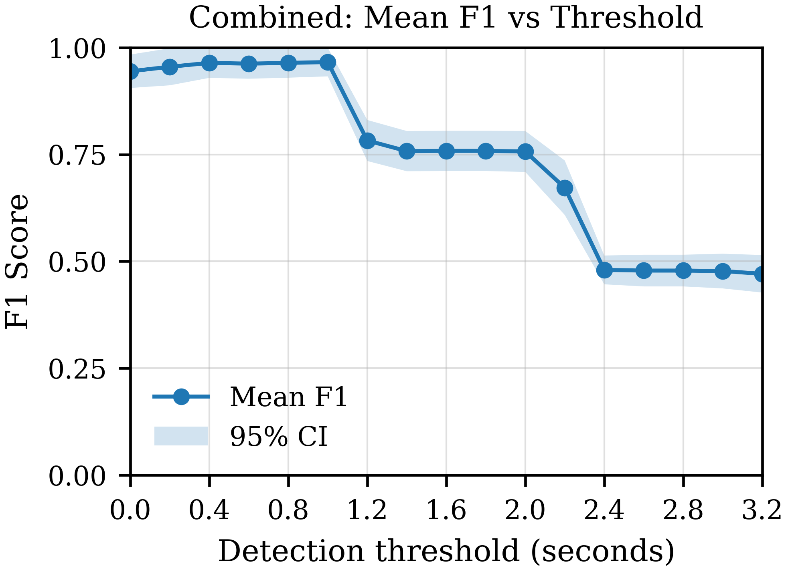
Fig. 8. Mean F1 score vs detection threshold T for the hybrid bench/daily-carry robustness test. Note: The stepwise drops in F1 score at T> 1.0s and >2.0s are artifacts of the test protocol, which used discrete puff durations of 1, 2, and 3 seconds.

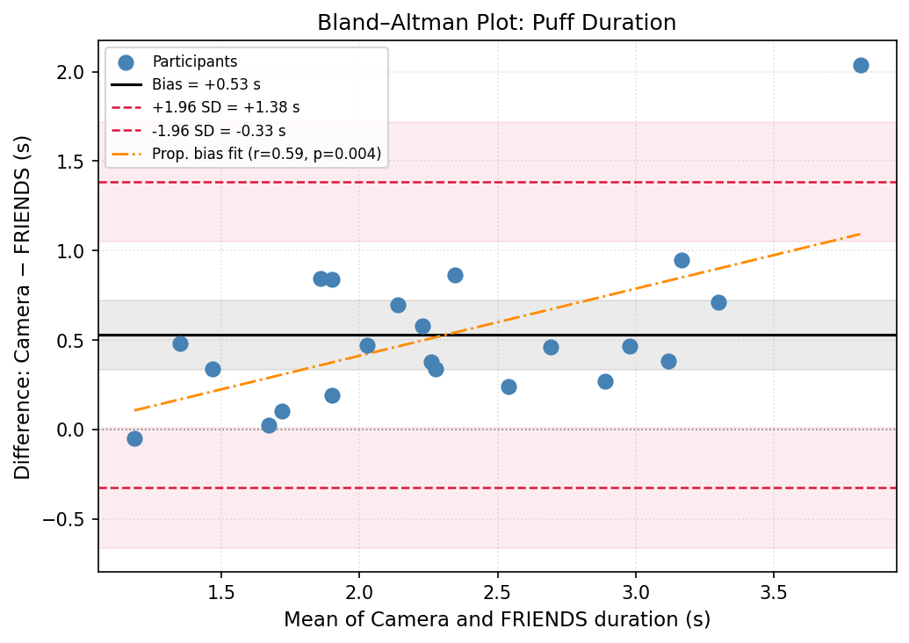
Fig. 9. Bland–Altman plot comparing video-coded and FRIENDS-recorded puff durations across 22 participants. Each point represents one participant's mean puff duration. The horizontal axis shows the mean of the two methods; the vertical axis shows the difference (video minus FRIENDS). The solid black line indicates the mean bias (+0.53 s); dashed red lines indicate the 95% limits of agreement (−0.33 to +1.38 s); shaded bands represent the 95% confidence intervals around each line. The orange dash-dotted line shows the proportional-bias regression fit (r = 0.59, p = 0.004), indicating that disagreement between methods increases with puff duration.

Overall, Fig. 8 indicates that a detection threshold of 0.4s provided the most practical and robust balance between precision (0.98 ± 0.05) and recall (0.95 ± 0.06), achieving near-peak mean F1 performance (0.96 ± 0.03) with limited variability across days and devices. The 0.4 s threshold was fixed on the basis of this bench/daily-carry analysis prior to the human laboratory study and was not tuned on human data.

C. Laboratory Validation with Human Participants
The 22 participants had a mean age of 25.7 years, had been vaping daily or near-daily for an average of 6.3 years, and reported a mean of 35.6 vaping episodes per day; 59% self-identified as female. All participants used late-generation disposable ENDS during the laboratory visit: Geek Bar Pulse (n=11), RAZ DC25000 (n=5), Lost Mary MO20000 Pro (n=3), Off-Stamp X Cube (n=2), and Hyde IQ (n=1).
Video coding identified 866 puffs across the 22 sessions. FRIENDS detected 888 puffs, with 799 TP, 67 FN, and 73 FP. The remaining 16 (888 - 799 – 73) were duplicates, where a single video-coded puff was split into two or three separate FRIENDS detections. achieved a pooled precision, recall, and F1 score (mean ± 95% CI, cluster-robust ratio-of-totals with participant as the sampling unit) of 91.6% ± 7.2%, 92.3% ± 7.8%, and 91.9% ± 5.8%, respectively. At the participant level, mean precision, recall, and F1 score were 93.4% [87.0%, 97.6%], 92.4% [85.5%, 97.9%], and 92.0% [85.8%, 96.9%] (mean and 95% bootstrap CI, 10,000 resamples of the 22 participants). These estimators answer different questions: the pooled metric reflects overall detection performance across all detected puffs, weighted by each participant's contribution, whereas the participant-level mean treats each participant equally regardless of how many puffs they took. . When detection was restricted to FRIENDS puffs that temporally overlapped a touch sensor activation, precision remained high (0.93), but recall dropped sharply to 0.34, yielding a mean F1 of 0.5. Only 322 of 888 device-detected puffs (36%) were accompanied by a concurrent touch event, indicating that contact with the FRIENDS touch sensor was an unreliable proxy for ENDS holding during puffing. These results suggest that the touch sensor cannot serve as a gating criterion for puff detection without substantially increasing missed detections.
Mean video-coded puff duration across participants was 2.57 ± 0.83 s, compared to 2.05 ± 0.59 s from FRIENDS (mean ± SD). Participant-level means were strongly correlated (r = 0.87, p < 0.001), indicating that FRIENDS reliably captured individual differences in puff duration. The Bland–Altman plot showing the difference in puff duration between the two methods is shown in Fig. 9. The mean bias of 0.53 s (video longer than FRIENDS) is consistent with the fact that video coding captures mouthpiece-to-lip contact, which begins before and ends after atomizer activation. This offset is consistent with the difference between the behavioral definition of a puff (lip contact) and the electromechanical definition (atomizer energization). Whether the offset is stable within participants and devices was not tested in the present analysis and should not be assumed.

IV. Discussion
The FRIENDS device represents a departure from most conventional puff-topography approaches that require aerosol
to flow through external sensor assemblies. FRIENDS detects the near-field electromagnetic pulses generated by current flowing through the ENDS atomizer coil. This permits attachment to the exterior of the ENDS body without electrical connection to internal circuitry or pneumatic connection to the airpath. Many modern refillable, pod-based, and rechargeable ENDS employ pulse-width modulation of atomizer current, producing a continuous electromagnetic signature throughout each puff. However, some lower-cost closed-system disposables use simple on/off switching, generating only brief transients at puff onset and offset. For these devices, an optional thermistor positioned in the mouthpiece provides thermal confirmation that detected electrical events correspond to actual puffs. This multimodal approach combines electromagnetic detection as the primary channel with thermal confirmation as a secondary measure. This approach extends FRIENDS applicability across the ENDS spectrum while maintaining high accuracy across devices spanning disposable, pod, and refillable form factors.
Bench lifecycle testing demonstrated that FRIENDS maintained accurate puff detection across the full operational lifetime of each ENDS device, from full charge and e-liquid to depletion. Puff count accuracy was high across 26 devices, indicating that detection reliability does not degrade as battery voltage drops or e-liquid is consumed. Agreement between FRIENDS-measured atomizer activation duration and programmed puff duration showed a mean relative error of 6.88% across devices, ranging from 0.74% for the Juul to 18.90% for the NJOY ACE. Because the inductive pickup detects atomizer coil activation directly, the recorded duration reflects actual heating element engagement rather than a proxy measure. The device-to-device variation in agreement with programmed puff duration likely reflects differences in how individual ENDS controllers manage atomizer activation, such as startup delays or power tapering.
Hybrid bench/daily-carry robustness test was designed to isolate the effect of real-world interference from consumer electronics, body movement, variable pocket orientations, and temperature fluctuations from the variability of human vaping behavior, by using machine-generated puffs as a known reference during daily carry. Over five days of continuous wear without recharging the FRIENDS device, the system achieved 97.6% ± 4.8% precision and 95.5% ± 6.2% recall at the detection threshold of 0.4s. Both device categories maintained high performance: the NJOY ACE (pod system, inductive pickup alone) and the Geek Bar Pulse X (rechargeable disposable, thermistor-assisted detection). The modest reduction in accuracy from bench to hybrid conditions quantifies the cost of real-world electromagnetic exposure at approximately 2–3 percentage points, confirming that environmental interference is manageable with threshold-based filtering, which is simple and interpretable. Threshold selection showed stable out-of-fold performance for 0.4s threshold that was used in the laboratory validation.
Laboratory validation with human participants confirmed that FRIENDS accurately detects naturalistic vaping behavior, achieving an average F1 score of 0.92 against video-coded ground truth. These results reflect the additional variability introduced by natural puffing behavior, including short puffs, rapid puff clusters, and variable device handling, that may not be captured by machine-generated protocols.
The touch sensor analysis revealed that only 36% of detected puffs were accompanied by a concurrent touch event, resulting in sharply reduced recall (0.34) when touch was used as a gating criterion. This finding indicates that participants frequently vape without maintaining sustained contact with the FRIENDS touch sensor, likely holding the ENDS body itself rather than the attached monitor.
The strong correlation between FRIENDS-measured and video-coded puff durations (r = 0.87, p &amp;lt; 0.001) confirms that the device reliably captures individual differences in puffing behavior. The bias of 0.53 s (FRIENDS shorter than video) is interpreted primarily as a difference in construct between a behavioral definition of puff duration (mouthpiece-to-lip contact) and an electromechanical one (atomizer energization), rather than as measurement error alone; the two contributions cannot be separated with the present reference standard. For research applications, atomizer-activation duration may be the more relevant quantity, as it is one determinant of aerosol generation, together with coil power, airflow, puff volume, e-liquid properties, and device control behavior. FRIENDS does not measure inhaled aerosol mass or delivered nicotine dose, and activation duration should not be interpreted as a direct measure of either. Although comparison with commercial puff-topography systems would be useful for cross-platform benchmarking, validity can be established directly against independent ground-truth references, such as video observation or controlled puff generators
The FRIENDS device imposes minimal burden on users: it requires no interaction during operation, provides no feedback that might influence behavior, and attaches unobtrusively to the ENDS body. These characteristics suggest potential for low reactivity compared to conventional topography systems, though this advantage will need to be confirmed experimentally.
FRIENDS builds upon our prior work on the Personal Automatic Cigarette Tracker (PACT) system for monitoring combustible cigarette smoking [33], [34], [35], [36], [37]. However, FRIENDS favorably compares both in terms of accuracy and user burden. In laboratory human testing, FRIENDS achieved an F1 score of 0.92, whereas PACT achieved an F1 score of 0.83 for smoke inhalation detection. FRIENDS also imposes lower user burden because PACT required breathing sensors [38], [39], wrist-mounted IMUs [40], and other sensors to detect smoking events and individual puffs. The performance advantage reflects the difference in sensing strategy: whereas PACT infers puffs indirectly from breathing patterns and hand gestures, FRIENDS detects atomizer activation directly, a signal that occurs exclusively during vaping. This transition from body-worn behavioral sensing to device-attached sensing represents a significant simplification that may facilitate larger-scale deployment in population studies of ENDS use.
Several limitations of the current FRIENDS implementation need to be acknowledged. The device, which was designed during the “chip shortage” of the COVID-19 pandemic, utilized an underpowered processor that was available at the time but lacked many dedicated peripherals (such as a serial port). Further, during data transfer, spurious interrupts from the touch or RF sensor caused missing bytes in serial transmission or disrupted data written into flash. Additionally, while the thermistor extends compatibility to ENDS devices lacking consistent PWM signatures, its placement within the mouthpiece requires drilling a small hole and sealing around the sensor. While this physical modification introduces some invasiveness relative to the otherwise non-contact design of FRIENDS, it remains substantially less intrusive than approaches requiring direct electrical connection to ENDS circuitry (e.g., PuffPacket). These observations will guide the development of the next generation of the FRIENDS device.
Several further limitations bound the interpretation of these results. First, FRIENDS is non-contact only for ENDS that modulate atomizer current; for selected on/off devices, detection requires a thermistor inserted through a drilled and resealed mouthpiece. The effect of this modification on draw resistance, airflow, aerosol deposition, and user behavior was not measured. Second, no unsupervised free-living human data are reported. The five-day daily-carry experiment used machine-generated reference puffs and therefore characterizes environmental robustness, not natural vaping behavior; the human validation was supervised, video-observed, and two hours in duration. Third, generalization is limited to devices that pass the model-specific compatibility and placement procedure. ENDS that were not detectable during screening, and devices that lost detectability while otherwise operating normally, indicate that compatibility cannot be assumed for an arbitrary ENDS model. Fourth, the human sample was concentrated in late-generation disposable ENDS, so the human results should not be extrapolated to pod, pod-mod, or refillable systems without further validation. Fifth, because the present study did not use a calibrated magnetic-field or current source, an absolute minimum detectable field or dI/dt cannot be reported; the grid-mapping procedure characterizes sensitivity in practical rather than absolute terms. Sixth, FRIENDS measures atomizer activation; it does not measure inhalation, puff volume, aerosol mass, or delivered nicotine dose.
Future hardware revisions will be based on a more capable processor. Validation studies with human participants in free-living conditions are planned to characterize detection performance across the full range of naturalistic vaping behaviors. Future studies comparing vaping behavior with and without FRIENDS attached will be necessary to confirm that the device does not alter natural use patterns.
We have made the FRIENDS platform publicly available to support replication and reuse by the research community. The open-source resources include the FRIENDS hardware design files and firmware, the FRIENDS GUI for device configuration, data extraction, decoding, and visualization, and the VM-FRIENDS vaping machine; these materials are available through the public GitHub repositories cited in [28], [29], [41], [42]. The data supporting the results reported in this paper are also provided through these repositories. In addition, device compatibility results and recommended deployment information for supported ENDS are maintained through the open-source FRIENDS Vape Library [30].
Overall, we believe that FRIENDS devices will contribute to advancing the objective measurement of ENDS use behavior in research and clinical applications.
V. Conclusion
This paper presented FRIENDS, a novel open-source instrumentation system for objective measurement of ENDS vaping behavior. Across validation studies, FRIENDS demonstrated strong performance: bench lifecycle testing across 26 ENDS showed highly accurate puff counting with low mean atomizer activation duration error, hybrid bench/daily-carry robustness testing with machine-generated reference puffs showed robust operation under environmental interference encountered during daily carry, and supervised laboratory validation with 22 participants showed good agreement with video-coded vaping behavior.
These findings indicate that FRIENDS is a practical tool for research applications requiring low user burden, flexible deployment, and objective characterization of vaping behavior. Potential applications include studies of ENDS dependence, naturalistic puffing patterns, product comparisons, and evaluation of behavioral, clinical, or regulatory interventions. Future work will focus on improved hardware, expanded human free-living validation, and continued growth of the compatibility library to keep pace with the evolving ENDS marketplace.
References
[1] C. for T. Products, “E-Cigarettes, Vapes, and other Electronic Nicotine Delivery Systems (ENDS),” FDA, Jun. 2024, Accessed: Jul. 02, 2024. [Online]. Available: https://www.fda.gov/tobacco-products/products-ingredients-components/e-cigarettes-vapes-and-other-electronic-nicotine-delivery-systems-ends
[2] R. O’Connor, L. M. Schneller, N. J. Felicione, R. Talhout, M. L. Goniewicz, and D. L. Ashley, “Evolution of tobacco products: recent history and future directions,” Tob. Control, vol. 31, no. 2, pp. 175–182, Mar. 2022, doi: 10.1136/tobaccocontrol-2021-056544.
[3] J. Schulenberg, L. Johnston, P. O’Malley, J. Bachman, R. Miech, and M. Patrick, Monitoring the Future national survey results on drug use, 1975-2019: Volume II, college students and adults ages 19-60. 2020.
[4] R. A. Arrazola, “Notes from the Field: Tobacco Product Use Among Adults — United States, 2017–2023,” MMWR Morb. Mortal. Wkly. Rep., vol. 74, 2025, doi: 10.15585/mmwr.mm7407a3.
[5] R. Mermelstein et al., “Tobacco control research priorities for the next decade: working group recommendations for 2016-2025,” Rockv. MD Natl. Cancer Inst., 2016.
[6] G. St.Helen and D. L. Eaton, “Public Health Consequences of e-Cigarette Use,” JAMA Intern. Med., vol. 178, no. 7, pp. 984–986, Jul. 2018, doi: 10.1001/jamainternmed.2018.1600.
[7] A. C. Villanti et al., “How do we determine the impact of e-cigarettes on cigarette smoking cessation or reduction? Review and recommendations for answering the research question with scientific rigor,” Addiction, vol. 113, no. 3, pp. 391–404, 2018, doi: https://doi.org/10.1111/add.14020.
[8] J. Yingst et al., “Measurement of electronic cigarette frequency of use among smokers participating in a randomized controlled trial,” Nicotine Tob. Res., vol. 22, no. 5, pp. 699–704, 2020.
[9] S.-H. Zhu et al., “Four hundred and sixty brands of e-cigarettes and counting: implications for product regulation,” Tob. Control, vol. 23, no. suppl 3, pp. iii3–iii9, 2014.
[10] J. Foulds et al., “Development of a questionnaire for assessing dependence on electronic cigarettes among a large sample of ex-smoking E-cigarette users,” Nicotine Tob. Res., vol. 17, no. 2, pp. 186–192, 2015.
[11] V. B. Mikheev et al., “The application of commercially available mobile cigarette topography devices for e-cigarette vaping behavior measurements,” Nicotine Tob. Res., vol. 22, no. 5, pp. 681–688, 2020.
[12] R. Underly, G. M. Dull, E. Nudi, T. Pionk, K. Prevette, and J. Smith, “Using a Novel Connected Device for the Collection of Puffing Topography Data for the Vuse Solo Electronic Nicotine Delivery System in a Real-World Setting: Prospective Ambulatory Clinical Study,” JMIR Form. Res., vol. 7, p. e49876, Oct. 2023, doi: 10.2196/49876.
[13] A. T. Adams, I. Mandel, A. Shats, A. Robin, and T. Choudhury, “PuffPacket: A Platform for Unobtrusively Tracking the Fine-grained Consumption Patterns of E-cigarette Users,” in Proceedings of the 2020 CHI Conference on Human Factors in Computing Systems, in CHI ’20. New York, NY, USA: Association for Computing Machinery, Apr. 2020, pp. 1–12. doi: 10.1145/3313831.3376373.
[14] X. Gao, M. Fewx, J. Sprock, H. Jiang, Y. Gao, and Y. Liu, “A Novel Puff Recording Electronic Nicotine Delivery System for Assessing Naturalistic Puff Topography and Nicotine Consumption During Ad Libitum Use: Ancillary Study,” JMIR Form. Res., vol. 7, no. 1, p. e42544, Jan. 2023, doi: 10.2196/42544.
[15] K. Kolaczyk and H. Jiang, “Photometric Monitoring of Electronic Cigarette Puff Topography,” Sensors, vol. 23, no. 19, Art. no. 19, Jan. 2023, doi: 10.3390/s23198220.
[16] E. Floyd, T. Oni, C. Cai, B. Rehman, J. Hwang, and T. Watson, “Validation of a High Flow Rate Puff Topography System Designed for Measurement of Sub-Ohm, Third Generation Electronic Nicotine Delivery Systems,” Int. J. Environ. Res. Public. Health, vol. 19, no. 13, Art. no. 13, Jan. 2022, doi: 10.3390/ijerph19137989.
[17] R. J. Robinson, E. C. Hensel, P. N. Morabito, and K. A. Roundtree, “Electronic Cigarette Topography in the Natural Environment,” PLOS ONE, vol. 10, no. 6, p. e0129296, Jun. 2015, doi: 10.1371/journal.pone.0129296.
[18] Y. Wang et al., “PuffEM: An E-cigarette Sleeve for Estimating User Nicotine Intake,” in Proceedings of the ACM/IEEE International Conference on Connected Health: Applications, Systems and Engineering Technologies, in CHASE ’25. New York, NY, USA: Association for Computing Machinery, Nov. 2025, pp. 129–133. doi: 10.1145/3721201.3721393.
[19] “Instruments,” Körber Technologies. Accessed: May 12, 2025. [Online]. Available: https://www.koerber-technologies.com/en/products/instruments
[20] S. D. Jesus, A. Hsin, G. Faulkner, and H. Prapavessis, “A systematic review and analysis of data reduction techniques for the CReSS smoking topography device,” J. Smok. Cessat., vol. 10, no. 1, pp. 12–28, Jun. 2015, doi: 10.1017/jsc.2013.31.
[21] T. R. Spindle, A. B. Breland, N. V. Karaoghlanian, A. L. Shihadeh, and T. Eissenberg, “Preliminary results of an examination of electronic cigarette user puff topography: the effect of a mouthpiece-based topography measurement device on plasma nicotine and subjective effects,” Nicotine Tob. Res., vol. 17, no. 2, pp. 142–149, Feb. 2015, doi: 10.1093/ntr/ntu186.
[22] N. J. Felicione, N. Karaoghlanian, A. Shihadeh, T. Eissenberg, and M. D. Blank, “Comparison of Measurement Methods for Electronic Cigarette Puff Topography,” Tob. Regul. Sci., vol. 6, no. 5, pp. 318–330, Sep. 2020, doi: 10.18001/TRS.6.5.2.
[23] Y. Qu, H. Hu, J. Liu, Z. Zhang, Y. Li, and X. Ge, “Driver State Monitoring Technology for Conditionally Automated Vehicles: Review and Future Prospects,” IEEE Trans. Instrum. Meas., vol. 72, pp. 1–20, 2023, doi: 10.1109/TIM.2023.3301060.
[24] B. Andò et al., “A Measurement System to Monitor Postural Behavior: Strategy Assessment and Classification Rating,” IEEE Trans. Instrum. Meas., vol. 69, no. 10, pp. 8020–8031, Oct. 2020, doi: 10.1109/TIM.2020.2967498.
[25] W. Lu, X. Liu, Y. Peng, M. Kyrarini, K. An, and Y. Cheng, “PACR-DETR: A Real-Time End-to-End Object Detector for Behavior Recognition in Various Classroom Scenarios,” IEEE Trans. Instrum. Meas., vol. 74, pp. 1–20, 2025, doi: 10.1109/TIM.2025.3550238.
[26] M. Sakthivel, B. George, and M. Sivaprakasam, “A New Inductive Proximity Sensor Based Guiding Tool to Locate Metal Shrapnel During Surgery,” IEEE Trans. Instrum. Meas., vol. 63, no. 12, pp. 2940–2949, Dec. 2014, doi: 10.1109/TIM.2014.2326767.
[27] B. Andò, S. Baglio, S. Castorina, R. Crispino, and V. Marletta, “A Methodology for the Development of Low-Cost, Flexible Touch Sensor for Application in Assistive Technology,” IEEE Trans. Instrum. Meas., vol. 70, pp. 1–10, 2021, doi: 10.1109/TIM.2020.3019882.
[28] S. I. Pranto, B. Fassler, M. R. Islam, A. Schenkel, L. W. Hawk, and E. Sazonov, “FRIENDS GUI: A Graphical User Interface for Data Collection and Visualization of Vaping Behavior from a Passive Vaping Monitor,” J. Open Res. Softw., vol. 14, no. 1, Apr. 2026, doi: 10.5334/jors.613.
[29] eszsonic, eszsonic/FRIENDSGUI. (Apr. 23, 2025). Python. Accessed: Dec. 09, 2025. [Online]. Available: https://github.com/eszsonic/FRIENDSGUI
[30] “Computer Laboratory of Ambient and Wearable Systems - FRIENDS vape library.” Accessed: Dec. 09, 2025. [Online]. Available: https://claws.eng.ua.edu/research-projects/44-friends/299-friends-vape-library
[31] “Computer Laboratory of Ambient and Wearable Systems - FRIENDS v1 TESTING SOP.” Accessed: Apr. 13, 2026. [Online]. Available: https://claws.eng.ua.edu/research-projects/44-friends/300-friends-v1-testing-sop
[32] B. Fassler, L. Hawk, M. Goniewicz, and E. Sazonov, “Open - Source Low-Cost Vaping Machine for Laboratory Testing of Electronic Nicotine Delivery Systems,” in 2025 International Conference on Machine Intelligence and Smart Innovation (ICMISI), May 2025, pp. 231–235. doi: 10.1109/ICMISI65108.2025.11115183.
[33] E. Sazonov, P. Lopez-Meyer, and S. Tiffany, “A Wearable Sensor System for Monitoring Cigarette Smoking,” J. Stud. Alcohol Drugs, vol. 74, no. 6, p. 956, Nov. 2013.
[34] P. Lopez-Meyer, Y. Patil, T. Tiffany, and E. Sazonov, “Detection of Hand-to-Mouth Gestures Using a RF Operated Proximity Sensor for Monitoring Cigarette Smoking,” Open Biomed. Eng. J., vol. 9, pp. 41–49, Apr. 2013, doi: 10.2174/1874120701307010041.
[35] P. Lopez-Meyer, S. Tiffany, Y. Patil, and E. Sazonov, “Monitoring of cigarette smoking using wearable sensors and support vector machines,” IEEE Trans. Biomed. Eng., vol. 60, no. 7, pp. 1867–1872, Jul. 2013, doi: 10.1109/TBME.2013.2243729.
[36] M. H. Imtiaz, R. I. Ramos-Garcia, V. Y. Senyurek, S. Tiffany, and E. Sazonov, “Development of a Multisensory Wearable System for Monitoring Cigarette Smoking Behavior in Free-Living Conditions,” Electronics, vol. 6, no. 4, Dec. 2017, doi: 10.3390/electronics6040104.
[37] V. Senyurek, M. Imtiaz, P. Belsare, S. Tiffany, and E. Sazonov, “Cigarette Smoking Detection with an Inertial Sensor and a Smart Lighter,” Sensors, vol. 19, no. 3, Jan. 2019, doi: 10.3390/s19030570.
[38] G. Karacocuk et al., “Inertial Sensor-Based Respiration Analysis,” IEEE Trans. Instrum. Meas., vol. 68, no. 11, pp. 4268–4275, Nov. 2019, doi: 10.1109/TIM.2018.2889363.
[39] G. Cosoli, L. Antognoli, L. Panni, and L. Scalise, “Indirect Estimation of Breathing Rate Using Wearable Devices,” IEEE Trans. Instrum. Meas., vol. 73, pp. 1–8, 2024, doi: 10.1109/TIM.2024.3372222.
[40] S. Wang, T. Zhang, Y. Li, P. Li, H. Wu, and K. Li, “Continuous Hand Gestures Detection and Recognition in Emergency Human-Robot Interaction Based on the Inertial Measurement Unit,” IEEE Trans. Instrum. Meas., vol. 73, pp. 1–15, 2024, doi: 10.1109/TIM.2024.3440381.
[41] “General · eszsonic/FRIENDS,” GitHub. Accessed: Dec. 09, 2025. [Online]. Available: https://github.com/eszsonic/FRIENDS
[42] eszsonic, eszsonic/VMFRIENDS. (Apr. 23, 2025). Python. Accessed: Dec. 09, 2025. [Online]. Available: https://github.com/eszsonic/VMFRIENDS


Edward Sazonov (IEEE M’02, SM’11) received the Diploma of Systems Engineer from Khabarovsk State University of Technology, Russia, in 1993 and the Ph.D. degree in Computer Engineering from West Virginia University, Morgantown, WV, in 2002. Currently he is a James R. Cudworth endowed Professor in the Department of Electrical and Computer Engineering at the University of Alabama, Tuscaloosa, AL and the head of the Computer Laboratory of Ambient and Wearable Systems (http://claws.eng.ua.edu). His research interests span wearable devices, sensor-based behavioral informatics and methods of biomedical signal processing and pattern recognition. Devices developed in his laboratory include a wearable sensor for objective detection and characterization of food intake (AIM – Automatic Ingestion Monitor); a highly accurate physical activity and gait monitor integrated into a shoe insole (SmartStep, winner of Bluetooth Innovation WorldCup 2009); a wearable sensor system for monitoring of cigarette smoking (PACT); and others. He has published over 100 journal papers and 150 conference papers / abstracts, and has 7 issued patents. In 2020 Dr. Sazonov served as a Fulbright Distinguished Chair at the University of Newcastle, Australia. His research has been supported by the National Institutes of Health, National Science Foundation, National Academies of Science, as well as by state agencies, private industry and foundations. Dr. Sazonov served as organizing committee member for many IEEE conferences, such as IEEE Sensors, IEEE Biomedical Health Informatics, IEEE Engineering in Medicine and Biology, and others.


Brett Fassler received the B.S. degree in electrical engineering from The University of Alabama in 2024 and the M.S. degree in electrical engineering from The University of Alabama in 2025.


Md. Rafi Islam received his B.Sc. in electrical and electronic engineering from Chittagong University of Engineering and Technology (CUET), Bangladesh, in 2017. He is currently pursuing a Ph.D. in electrical engineering at The University of Alabama, Tuscaloosa, AL, USA.
He previously worked as a Lecturer in the Department of Electrical and Electronic Engineering at Premier University, Chittagong. His research interests include embedded systems, machine learning, and wearable sensors.


Ashley Schenkel received her B.A. in psychology from D'Youville University in Buffalo, NY. She is currently a Clinical Research Coordinator at the University at Buffalo Behavioral Health Lab, Buffalo, NY, USA (PI: Dr. Larry Hawk). Her research interests include behavioral mechanisms associated with continued use and dependence to nicotine products, particularly electronic nicotine delivery systems.


Delwar Hossain received the Ph.D. degree in electrical engineering from The University of Alabama, Tuscaloosa, AL, USA, in August 2024. His research interests include the development of wearable systems, sensor networks, and machine learning algorithms for preventive, diagnostic, and assistive health technology.


Stephen T. Tiffany is an addiction scientist who has published numerous articles, book chapters, and books on drug craving, etiology of drug dependence, and interactions of biological and psychological factors in the control of addictive behaviors. He received his Ph.D. (Clinical Psychology) in 1984 from the Department of Psychology at the University of Wisconsin – Madison. From 1984 – 2002, he was on the faculty of the Department of Psychological Sciences at Purdue University, rising to the rank of Full Professor. In 2002, Dr. Tiffany joined the faculty as a Professor in the Department of Psychiatry in the University of Utah with a joint appointment in the Department of Psychology. Dr. Tiffany joined the faculty of the University at Buffalo, SUNY in 2007 as an Empire Innovation Professor in the Department of Psychology. Dr. Tiffany was promoted to the rank of SUNY Distinguished Professor in 2020. From 2011 – 2018, Dr. Tiffany was the Chair of the Department of Psychology at the University at Buffalo. Dr. Tiffany was awarded the American Psychological Association Distinguished Scientific Award for Early Career Contribution to Psychology in 1993 and is a Fellow of the Society for Research on Nicotine and Tobacco. He has been on the editorial boards of several journals and was a Deputy Editor for Nicotine and Tobacco Research. He has also been a member of several NIH scientific review panels and was a member of the Scientific Core Group of the Robert Wood Johnson Foundation’s Tobacco Etiology Research Network (TERN). Dr. Tiffany has served as Principal Investigator on multiple major research grants from the federal government and private foundations. He has also been the major professor for 20 students who have received their Ph.D. in clinical psychology.


Larry Hawk is a behavioral scientist focused on nicotine and tobacco. His work combines laboratory studies and clinical trials to better understand and treat cigarette smoking and nicotine vaping. Dr. Hawk earned his Ph.D. in Medical/Clinical Psychology in 1996. He has been on faculty in the Department of Psychology at the University at Buffalo since 1997; he was promoted to Full Professor in 2014. Dr. Hawk’s research has been supported by the National Cancer Institute, the National Center for Advancing Translational Sciences, the National Institute on Drug Abuse, and the National Institute of Mental Health. He has authored/co-authored over 140 peer-reviewed articles. Dr. Hawk is a Fellow of the Association for Psychological Science and the Society for Research on Nicotine & Tobacco. He is currently a Deputy Editor for Nicotine & Tobacco Research.

Research reported in this publication was supported by the National Cancer Institute of the National Institutes of Health under Award Number R01CA266170. The content is solely the responsibility of the authors and does not necessarily represent the official views of the National Institutes of Health. Edward Sazonov, Brett Fassler, Delwar Hossain and Md. Rafi Islam are with the Department of Electrical and Computer Engineering, The University of Alabama, Tuscaloosa, AL 35487 USA (e-mail: esazonov@ua.edu; brfassler@crimson.ua.edu; dhossain@ua.edu; mislam24@crimson.ua.edu). Larry Hawk, Stephen Tiffany and Ashley Schenkel are with Department of Psychology, University at Buffalo, The State University of New York, Buffalo, NY 12246, USA; (e-mail: lhawk@buffalo.edu; stiffany@buffalo.edu; aschenke@buffalo.edu). All human research procedures were approved by the Institutional Review Board at the University at Buffalo.

